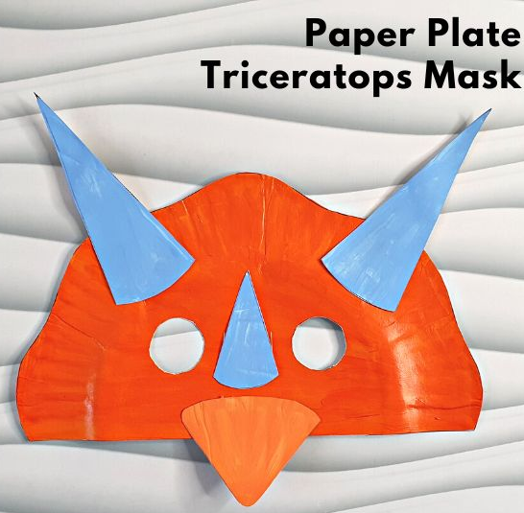
Materials: Paper plate, scissors, paper pieces, glue, markers/coloring utensils (optional)
Instructions:
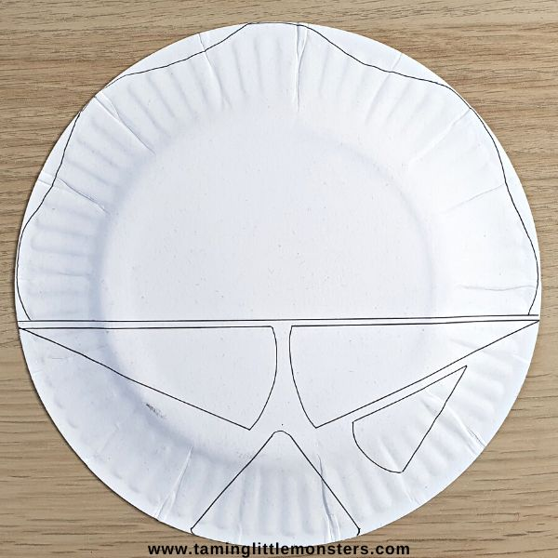
- Draw a line right across the paper plate, just below halfway. Then on the larger side of the plate, draw wavy lines around the edges, to make the frill. On the bottom part of the plate, draw two large and one small isosceles triangles, where it was roughly twice as high as it was wide. These are the three horns. Draw another triangle, for the beak.
- Cut paper plate in half, cut a wavy design at top, cut two holes for eyes, cut out horns and beak
- Color paper plate half if desired
- Glue on horns and beak, color if desired
- Let plate dry

