Air Dry Clay DIY Dinosaurs
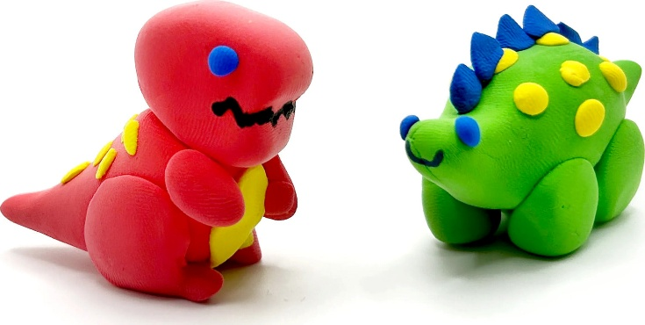
Materials:
- Air dry clay
- Rolling pin/bottom of cup
- Paint(optional)
- Brush (optional)
Instructions:
Let your imagination run wild! Create any kind of dinosaur that you would like. After the clay is dried, you can paint or color it with marker. Alternatively, if you have mini dinosaur figurines at home, you can roll out your clay and push in the dinosaur to make a ‘fossil’.

