Patron Referral Code Query
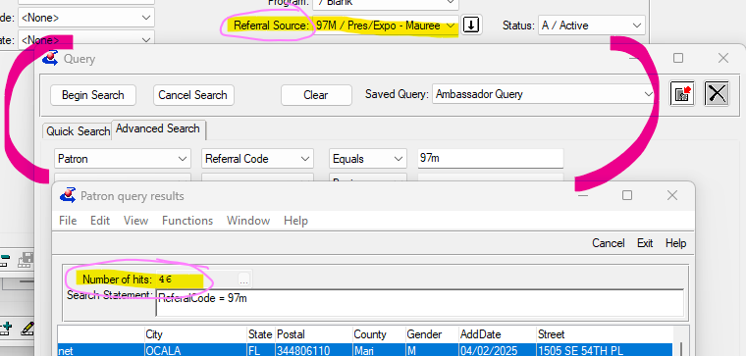

Patron - Referral Code - Begins/Equals
KLAS can set you up with specific codes as needed, and keep in mind, while the NLS application says you can pick up to 3, right now in KLAS it is one selection per person.
They need to code them so they point to one of NLS's categories, but they were able to expand one area for us to include each of our district office around Florida.
If you have additional notes you need to add, you can query for those too.
Patron - Referral Code - Begins/Equals
Preference - Type - begins - "NLSReferralSOurce"
Preference - Note - matches

